**GROUP 13- Rudrani Sakhare, Sophie Deveikis, Mohammad Al Najjar.**

Executive Summary: This data provides insights into H-1B applications and their approval rates, highlighting various companies, their sponsorship practices, and wage trends across different industries and states.Access to the Server:

User: prof_luis Password: 12345 Hostname: hult-13.mysql.database.azure.com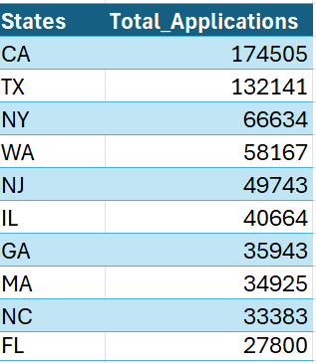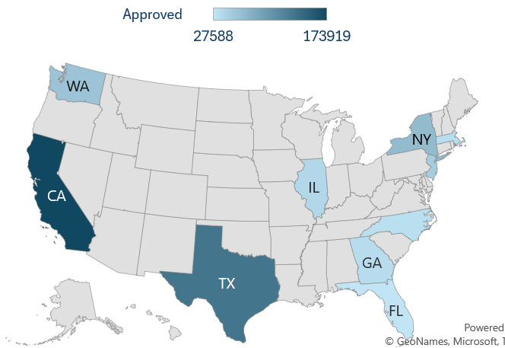

**BASED ON THE DATA**

**Analysis:** State-wise analysis of H1b Applications shows

Total applications, Approved and Denied Cases. Illustrating

the prevalence of H-1B sponsorship and the varying approval

rates across states.

**Recommendation**: The states mentioned above are the top 10

for H1Visa applications you can also look at states such as Florida

and Arizona For Healthcare, Manufacturing, and Microchip Industry.

(Refer for more State related Info [state rankings for jobs](https://www.usnews.com/news/best-states/rankings/economy/employment/job-growth)) **Analysis:** Top 10 employers with the Number of H1B Sponsorships from 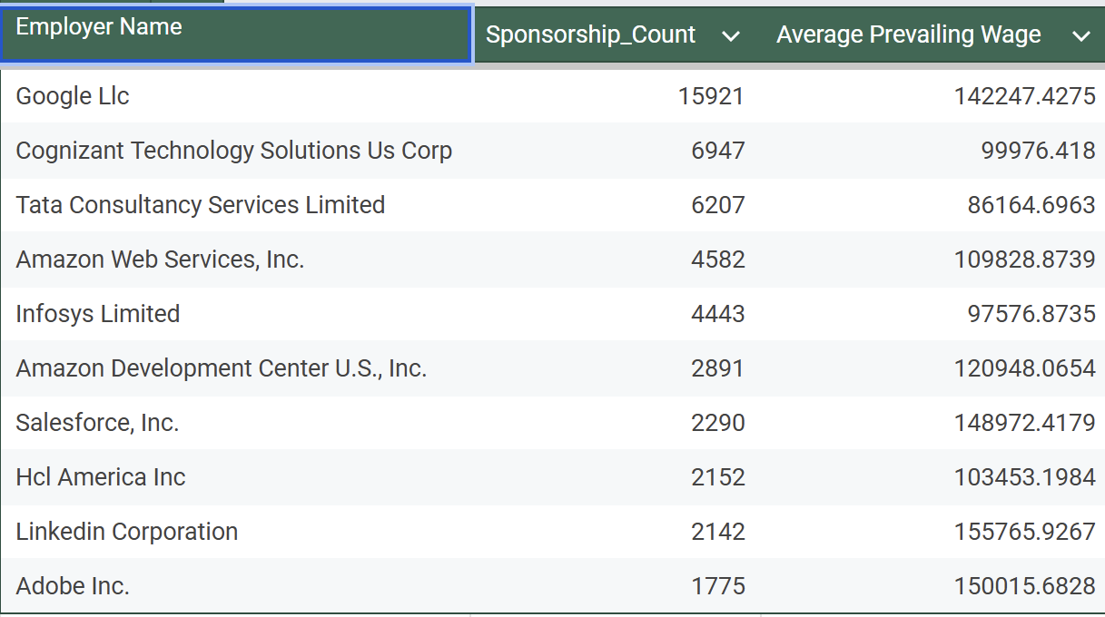

the data available from 2022 & 2024

**Recommendation:** Target high-sponsorship employers like Google and Tata

Consultancy for H1B opportunities, focusing on companies offering competitive

wages such as LinkedIn and Adobe. Enhance skill development aligned with

industry demands to increase employability and advocate for streamlined company

sponsorship processes.

**Hypothesis:** Democrat States have a higher Living Cost Index than Republican States. 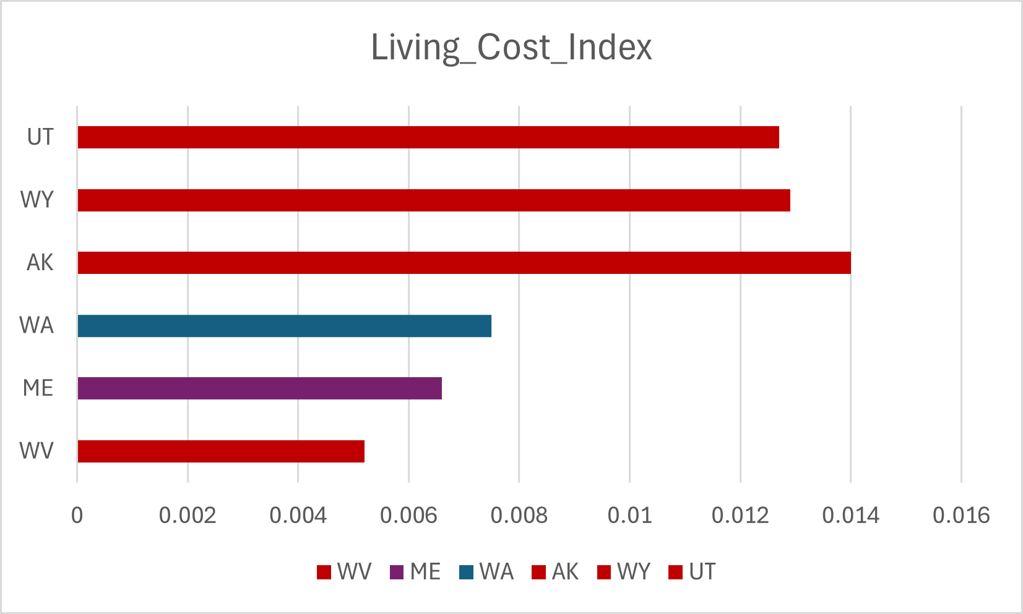

**Null-Hypothesis:** There is no difference in the Living Cost Index between Democratic and Republican

states.

**Alternative Hypothesis:** Democratic States do have higher Living Cost Index and better affordability than

Republican states

**Analysis:** West Virginia **(0.0052)**, Maine**(0.0066)**, and Washington**(0.0075)**

have the **lowest** Living Cost Index, indicating high affordability relative to wages,

while Alaska**(0.0140)**, Wyoming**(0.0129)**, and Utah**(0.0127)** have a **higher** cost

of living compared to wages.

**Conclusion:** The analysis failed to reject the null hypothesis, indicating no significant difference in Living Cost Index and affordability between Democratic and Republican states.

**Hypothesis:** An H-1B visa holder earning $80,000 might save $56,000 per year in low-cost areas with

living expenses of $24,000(calculated at 30% of income). This is computed by multiplying $80,000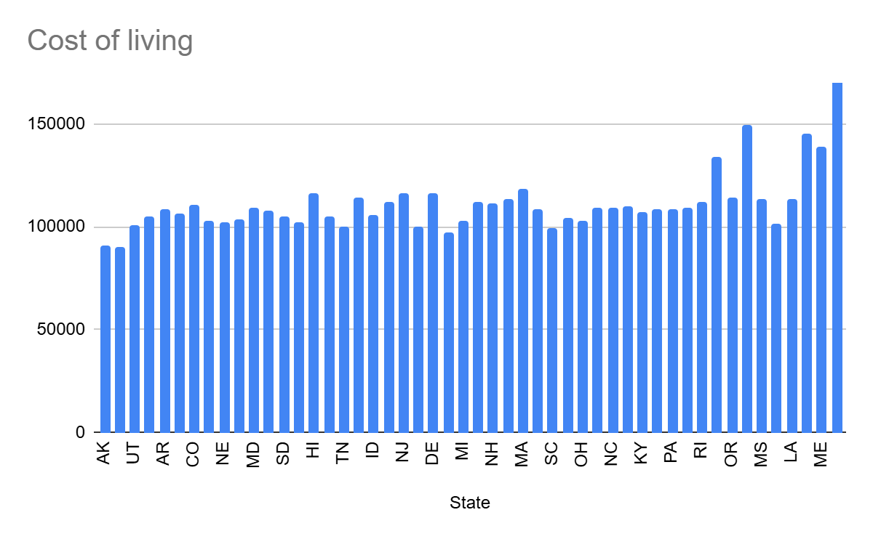

by 0.3 expenditures and subtracting the result from total income. In high-cost states, where living expenses

are predicted to be 50% of income (or $40,000) savings fall to $40,000. This approach demonstrates

how living expenses, expressed as a proportion of income, have a significant impact on financial stability

and savings capacity.

**Null Hypothesis** (H0): Based on the cost of living in various states, there are no appreciable variations

in the financial Circumstances and standard of living of H-1B visa holders.

**Alternative Hypothesis** (H1): In states where living expenses are lower than average income, H-1B visa

holders have better financial circumstances and a higher standard of living.

**Conclusion:** In low-cost states, holders of H-1B visas can save around $56,000 a year, while in high-cost

states, they can save $40,000 a year. This illustrates how living expenses have a direct influence on their

ability to save money and their standard of living, making the cost of living an important consideration

when deciding where to live and work.

**Recommendation:**

1. **Skill Development:** Continuously build your tech and data analysis skills through relevant certifications. Stay updated on emerging tools and trends, and aim to specialize in a high-impact area to stand out.
2. **Political Awareness:** Track state-specific political climates, as Democratic-led states typically have higher H1B certification rates and wages, indicating more favorable support for H1B holders.
3. **Leverage F1 Status:** Use Optional Practical Training (OPT) opportunities effectively to gain U.S.-based experience in your field. Engaging in internships or work experiences under OPT not only strengthens your skills but also increases your chances of H1B sponsorship by a future employer.
4. **Network Strategically:** Connect with alumni, industry professionals, and career centers to build relationships in your target states and industries. Networking is often key to finding companies open to H1B sponsorships
5. **Build Industry Knowledge:** Focus on analytics applications in sectors like finance, healthcare, or retail (e.g., risk analysis, consumer insights) to align with industry needs and boost employer appeal.
6. **Target Key States and Companies with High H1B Sponsorship**: Focus on high-certification states (California, New York, Washington, and New Jersey) and seek companies with strong H1B sponsorship histories in data-driven industries like tech, finance, and healthcare analytics.

References: United States Joint Economic Committee. (n.d.). *Massachusetts inflation update*. Retrieved November 3, 2024, from<https://www.jec.senate.gov/public/index.cfm/republicans/massachusetts-inflation-report/>

Ballotpedia. (n.d.). *Party affiliation of the mayors of the 100 largest cities*. Retrieved November 3, 2024, from [http://ballotpedia.org/Party_afillation_of_the_mayors_of_the_100_largest_citie](http://ballotpedia.org/Party_afillation_of_the_mayors_of_the_100_largest_cities)